THRONE: KINGDOM AT WAR FOR IOS AND ANDROID

Throne: Kingdom at War
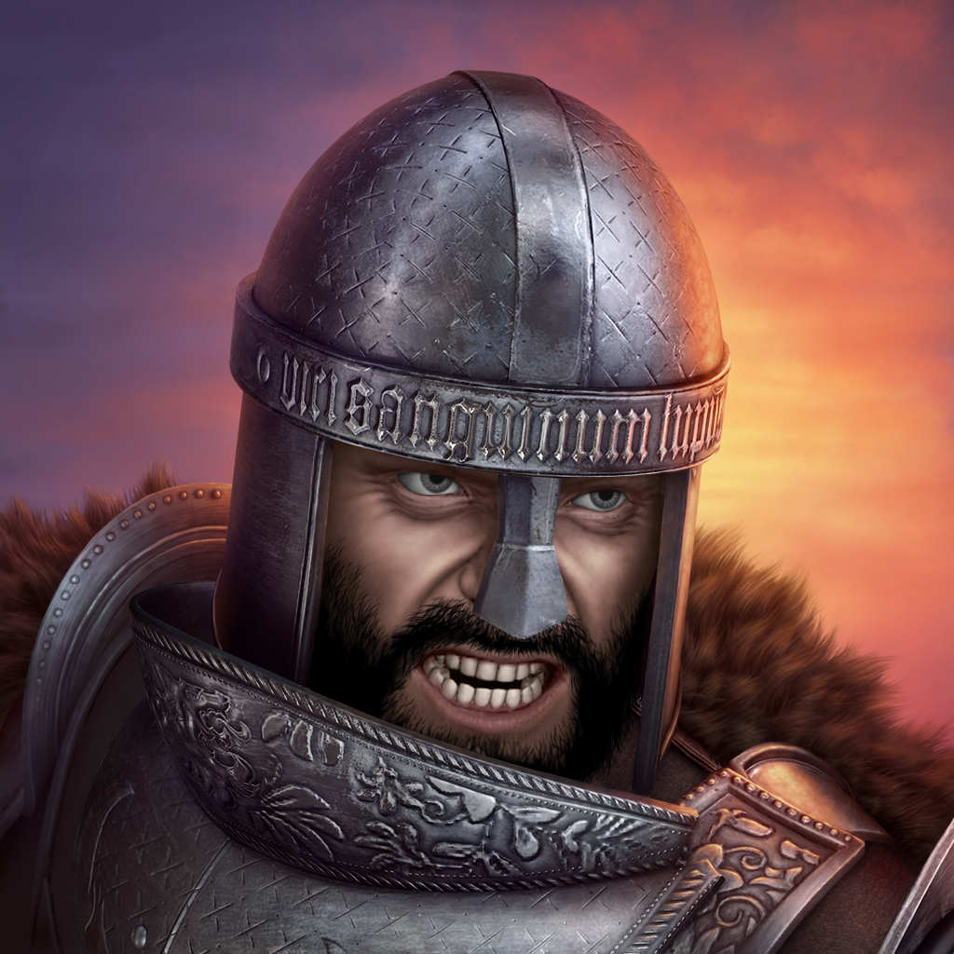
Throne: Kingdom at War immerses players in the fictional medieval realm of Amaria, where the late king’s rightful heirs call the shots and Lords from the furthest reaches of the Kingdom seek the crown to quench their thirst for power, might and gold.

Build your Town, train thousands of valiant warriors and assemble a powerful army capable of crushing any obstacles that stand in the way. Fight alone or together with allies, creating your own noble Order or join an existing one. Prove that you deserve to claim the throne and rule the Kingdom!

Throne: Kingdom at War is a new AAA mobile MMO strategy game with high-quality graphics and animation, intuitive user interface, and superior social engagement features to provide players a leading clan-based gameplay experience.

Key Features

Explore a New Medieval Reality with Traditional MMO Strategy Gameplay
- Construct your own Town: Create military and resource buildings, a Treasury to hold your riches, upgrade your Hero in the Manor and train dozens of units in six key troop types: Knights, Spearmen, Ranged, Cavalry, Siege and Scouts.
- Deep Hero customization: Level up your Hero and Skills according to your personal playing style. Create armor, weapons and equipment that grant considerable bonuses to various military and economic characteristics.
- Join an Order or create your own: Take up arms with fellow Lords or become your own Order Master and lead the charge against your opponents.

Become Part of an Eternal Struggle
- Global Tournaments: Take part in Tournaments that grant its victor the title of King, the ability to give Lords certain Reputations that increase or decrease their combat and economic characteristics, and the right to collect tribute in Silver.
- Capture resource locations on the Kingdom map and hold them while the resource is yielded.
- Participate in Quests and accomplish Errands: Gain Power points and become the strongest Lord by achieving the highest ranking.
- PvP or PvE gameplay: Form joint raids on enemy Towns, protect your own from other players, attack NPCs and ask your Order allies for reinforcements when you’re down to your last soldier.

Product Specifications

Publisher: Plarium
Developer: Plarium
Category: MMOS (Massively Multi-Player Online Strategy)
Platform: iOS, Android
MSRP: FREE
Release: August 25, 2016

© 2016 Plarium. All Rights Reserved. Plarium, Throne: Kingdom at War, and their respective logos are trademarks or registered trademarks of Plarium.

