SOLDIERS INC: MOBILE WARFARE FOR IOS AND ANDROID

Soldiers Inc: Mobile Warfare

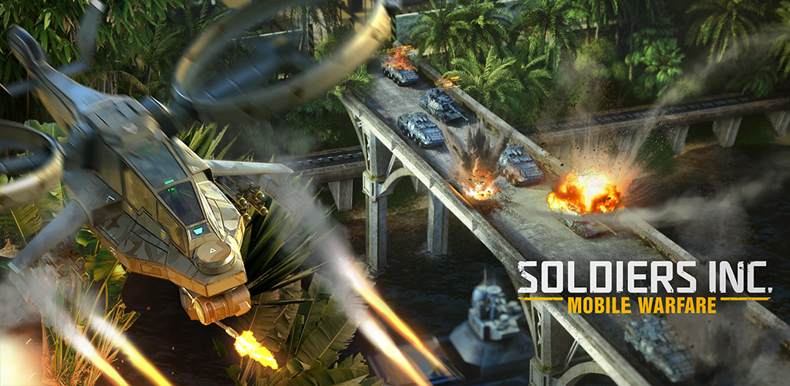
Soldiers Inc: Mobile Warfare is set in the fictional failed state of Selva de Fuego, located deep in the rainforests of South America. Selva de Fuego is the world’s only source of the miracle-drug Serum, the production of which is controlled by a rogue corporation: Phoenix Industries. The World Security Operation has recently declared war on Phoenix, giving every private military force permission to engage hostilities and seize control of the Black Sites where Serum is produced.

Players will build their base, hire seasoned soldiers of fortune, and equip them with cutting edge vehicles and weaponry to create a powerful army. Fight alone or together with allies, creating your own alliance or joining an existing one. Success in Selva de Fuego will come down to the survival of the fittest – so get tough, or get going.

Soldiers Inc: Mobile Warfare is a new AAA mobile MMO strategy game with high-quality graphics and animation, intuitive user interface, and superior social engagement features, providing players with a world-class clan-based gameplay experience.

Key Features

Explore a Futuristic Military Setting with
Traditional MMO Strategy Gameplay
- Build your Base: Focus on the production of resources and build storage facilities to keep your assets safe.
- Highly detailed 3D heroes: Choose an operative to lead your army, and give them powerful gear to level-up your armed forces.
- Choose from 26 units in four categories: Light Infantry, Mechanized Infantry, Armor, and Aviation.
- Battle and construct buildings to obtain the game’s key resources: rations, munitions, fuel, and diamonds.
- Join an alliance or create your own, cooperating with players from around the world to compete online in real-time massive multiplayer clan warfare.

Join the Fight in Global Player-vs. - Player Combat
- Take part in tournaments that pit commanders and alliances from around the world against each other for massive rewards.
- Seize control of resource sites across the map and defend them from enemy incursions.
- Fight against thousands of rival alliances in massive battles at black sites and alliance headquarters.
- Grow your alliance’s influence and improve members’ armies with special resources
- Complete challenging special ops missions and raid neighboring bases to establish dominance and claim resources
- Annexes: AddsF a deeper level of tactics to PvP clan warfare with a new system of strategic map site

Product Specifications

Publisher: Plarium
Developer: Plarium
Category: MMOS (Massively Multi-Player Online Strategy)
Platform: iOS, Android
MSRP: FREE
Release: November 30, 2016

© 2016 Plarium. All Rights Reserved. Plarium, Soldiers Inc: Mobile Warfare, and their respective logos are trademarks or registered trademarks of Plarium.

