NORDS: HEROES OF THE NORTH FOR FACEBOOK

Nords: Heroes of the North
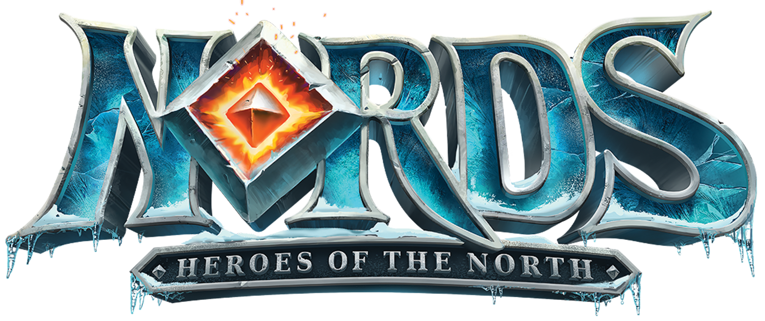
Nords: Heroes of the North is set in the fantasy world of Shingård where players must lead an army of Elves, Dragons, Northmen and Orcs who have set aside their differences to defend their land against an evil Ice Queen and her swarm of the undead as they aim to conquer the world.

Key Features

- All-New RPG Elements
- New inventory and item system add a level of depth never-before introduced in a Plarium game
- Players can collect and craft new equipment to arm their characters with weapons, armor and items for combat and production bonuses

- Traditional Hardcore MMO Strategy Gameplay
- ‘Choose Your Faction’ feature lets you choose which army to lead – Orcs, Elves or Northmen – to determine how your stronghold and environment will look to you and other players
- Customize your stronghold: Build your stronghold with forts, barracks and more.
- Frequent updates offering new units, content, gameplay features, storylines and strategies
- Interact with global players and friends while comparing your achievements in rankings

- Brand New 3D Animation:
- Battle Animation: For the first time ever, players can see and hear the action during battles. Animated battles let players see their current units in action while previewing new ones.
- Unit personalities: Characters have been given in-depth stories and backgrounds to immerse players more into the world and into their units
- Highest quality of 3D animation and content ever achieved in a Plarium game

- Design and Production
- Over 30 professional actors contributed their voices to Nords, including Patrick Warburton of “Family Guy” fame
- Fully-scored soundtrack and sound composed and produced by BAFTA award-winning composer Jesper Kyd
- Top-quality artwork and modeling with the level of detail demanded by the most serious players

Product Specifications

Publisher: Plarium
Developer: Plarium
Category: MMO Strategy (Massively Multiplayer Online Strategy)
Platform: Facebook
MSRP: FREE
Release: May 19, 2015

© 2015 Plarium. All Rights Reserved. Plarium, Nords: Heroes of the North, and their respective logos are trademarks or registered trademarks of Plarium.

